THE SALVATION ARMY

PART OF THIS ASSIGNMENT: YOU MUST VISIT THE SALVATION ARMY THRIFT SHOP ACROSS THE STREET FROM SVA.

The Salvation Army Thrift Shops get their items from people who donate them. Old clothes, old toys, electronics, albums, furniture, eye glasses, cocktail glasses, vintage jewelry, broken items.
Some items are in bad shape. The place smells. It looks crappy. The people are weird. It’s not an inviting shopping experience. It’s an unusual place to shop . But the items are cheap. And occasionally you can find something cool. And they use the money you spend to help the needy.
It has a lot of negatives. Get someone to shop there!

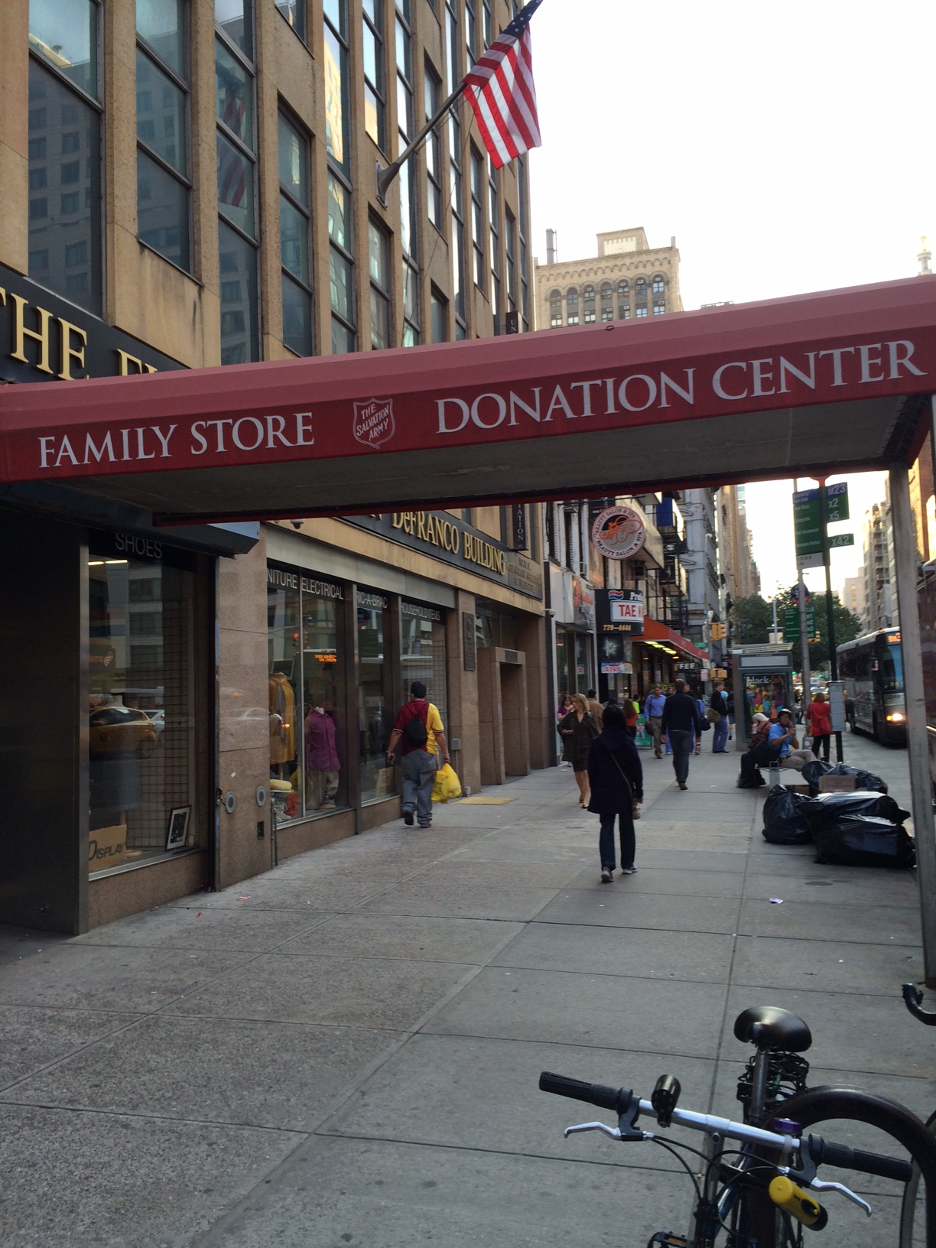
LOOK AROUND THE STORE: LOOK FOR…
1.THE WEIRDEST THING YOU SEE THERE.
2. THE MOST EXPENSIVE ITEM
3. THE CHEAPEST ITEM
4. SOMETHING YOU WOULD BUY.
5. SOMETHING YOU WOULD NEVER BUY.

THINK ABOUT:
•WHAT THE STORES OFFER THAT OTHER STORES DONT.

•WHY WOULD SOMEONE SHOP HERE.

•THE COMPETITION: WHERE ELSE DO PEOPLE SHOP FOR THE ITEMS YOU SEE IN THE STORE.

•WHERE DOES ALL THE STUFF COME FROM.

•WHAT KIND OF PEOPLE DONATE STUFF HERE.

•WHAT CAN YOU SAY TO CREATE INTEREST ABOUT THE STORE AND MOTIVATE SOMEONE TO SHOP THERE.

•WHERE CAN YOU PUT YOUR MESSAGE/ADVERTISEMENT.

GOAL: GET SOMEONE TO SHOP IN THE STORES.

